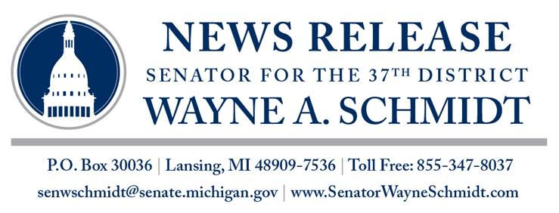
For Immediate Release
Feb. 16, 2017

Contact: Connie Russell
517-373-2413

Schmidt congratulates Chippewa County on MDOT grant

LANSING, Mich. — State Sen. Wayne Schmidt on Thursday congratulated the Chippewa County Road Commission upon being awarded a grant of more than $100,000 from the Michigan Department of Transportation (MDOT).

“This is great news for Chippewa County and Sault Ste. Marie,” said Schmidt, R-Traverse City. “The MDOT grant will go a long way toward improving one of the city’s roads.”

The Transportation Economic Development Fund Category F grant of $104,705 was awarded for Fiscal Year 2018 for construction costs on Ferry Dock Road in Sault Ste. Marie.

According to MDOT, Category F grants are competitive grants made to eligible road agencies to preserve and/or expand all-season road networks within the urban areas of rural counties.

